WHO’S THE BOSS? - A LOOK INTO THE ABIOTIC FACTORS CAUSING CHANGE TO COMMMUNITY COMPOSTION WITHIN A LOTIC MICROBIAL ECOSYTEM.

ABSTARCT
Despite the importance of bacteria in lotic ecosystems. They are understudied, with the main drivers of community change yet to be significantly determined. This study looks at 1.2km stretch of freshwater found at Lyme Park. This study attempts to establish how Ph and/or other abiotic factors effect community compositions in six sites. A significant difference in community composition was identified between acidic and neutral sites. And a positive relationship was calculated for the PH and metal concentrations. However, despite the results showing compositional change there were few OTU’s that had great abundance and distribution despite the disadvantageous conditions. Therefore, further research must be completed to get a better understanding of community composition and what effects it.
- INTRODUCTION
Bacteria are microscopic organisms that live in a world unseen by the naked eye. This unseen world is usually associated with sickness, disease, and death and overall bad connotations that our mothers would ‘wipe’ away in our protection. Nevertheless, bacteria are so much more than pathogenic! The microbiologist John Ingram stated that there are more murderers among humankind than pathogens among microbe’s (Guerrero, R., 2015). Therefore, pathogenic bacteria are the exception and not the rule.
Three factors make bacteria so interesting. Firstly, bacteria are believed to be among the oldest life forms to exist on our planet (Prosser et al., 2007). Furthermore, their phylogenetic and physiological diversity Is significantly more extensive than that of eukaryotic organisms like plants and animals that came much later (Gray and Campbell, 1980). Secondly, they are ubiquitous, being as bacterial communities constitute the majority of the earth’s biomass and can be found in all habitats around the world (Lijuan et al., 2014). Thirdly, what makes bacteria so remarkable is that they are the catalyst for many ecosystem services, which are vital in sustaining life on our planet (Lijuan et al., 2014).
One essential role bacterium play in maintaining life Is through the biogeochemical cycling processes in natural water ecosystems (Paruch et al., 2020). Aquatic bacteria are involved in respiration, organic and inorganic nutrient cycling and the diminution of chemical and biological pollutants (Zeglin, 2015). As a result of this, it is also thought that aquatic bacteria are closely associated with biological water quality and environmental health (Saxena, Bharagava, Kaithwas and Raj, 2014); therefore, having a comprehensive understanding of the mechanisms that regulate and/or change aquatic bacterial distribution, diversity, and composition is of great interest and ecological importance for future management and predication strategies for sustainable ecosystems functions (Hou et al., 2017).
This is where the study of microbial ecology comes to play. Microbial ecology investigates the diversity, abundance, and distribution of microorganisms and how they affect ecosystem function (Beisner et al., 2006; Vannote et al., 1980). There have been many theories proposed by microbial ecologists of what underpins bacterial community change. One popular theory was the 1934 Bass-Becking hypothesis (de Wit and Bouvier, 2006) ‘everything is everywhere (EisE) that states because of the small size and high dispersal potential that microscopic organisms have a cosmopolitan distribution (Kellogg and Griffin, 2006). However, this classical theory was heavily challenged by the emergence of advancing molecular techniques that found restricted dispersal in a range of different microorganisms and even in some organisms previously ‘proven’ to have a cosmopolitan distribution (FONTANETO et al., 2008; Smith and Wilkinson, 2007). Thus, another ecological theory emerged. This is the distance decay model that states that the greater the distance between communities, the greater the dissimilarity found in species composition (Astorga et al., 2011).
The present debate on microbial ecological theories has divided scientists. With one side favouring the distance decay model (Bell, 2010) and the other following the improved, everything is everywhere, but the environment selects hypothesis (de Wit and Bouvier, 2006). This suggests that the only difference seen in species composition is as a result of environmental differences and not restricted dispersal.
Aquatic bacterial communities can be studied at a wide scale. From enormous oceanic currents to humble stream networks (Morris et al., 2002; IVARS-MARTÍNEZ et al., 2008) but what makes them an excellent study site is the lateral and vertical movement of the water that enables the mixing and interactions of various abiotic and biotic factors that can lead to complex communities with their own ecological processes (Gweon et al., 2020). However, our knowledge of lotic bacterial ecology is lacking as we do not know for certain what ecological processes or factors drive the structure of these bacterial communities (Paruch et al., 2020).
This study aims to evaluate and understand the abiotic environmental factors possibly shaping bacterial community composition in a 1.2km stretch of a freshwater stream. This is a small-scale study in comparison to outside literature; however, outcomes of this study could lead to a better understanding of the effect of abiotic factors on lotic bacterial community structure. The hypothesis we will be testing is that fluctuations in PH cause changes in bacterial community composition along the studied lotic environment.

- METHODS
  - Lyme Park Study Site
The targeted study site is the National trusts Lyme Park, Disley Stockport SK12 2NR (Figure 1). Here we followed a freshwater stream roughly around 1.2 kilometres exiting moorland grassland downstream to a public car park.
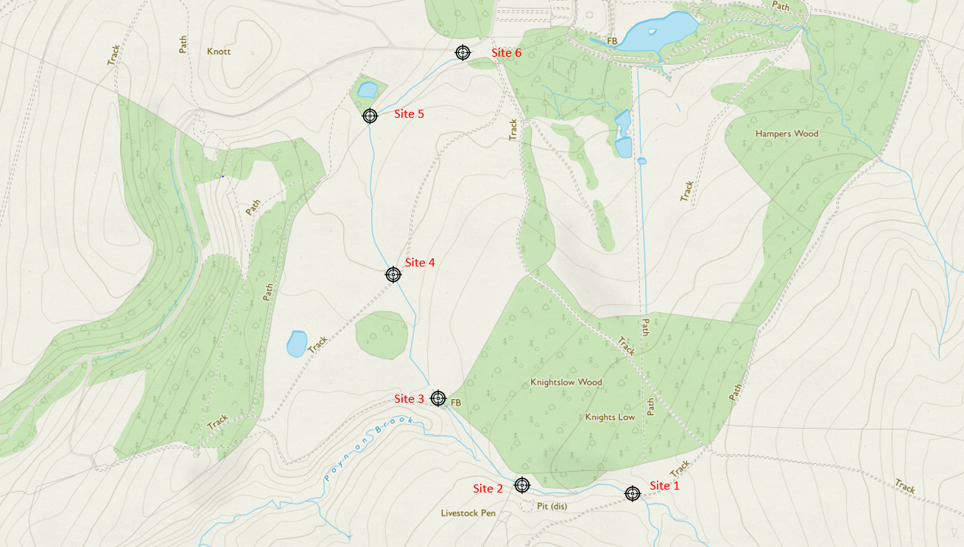
Figure 1. shows a geographical map of the study site, Lyme Park. And the coordinates of the six sites tested along the stream continuum.

  - Sample collection
All sampling was conducted during a time of low water-flow conditions in early winter on Wednesday, November 17th, 2021. At the national trust water samples (500ml) were collected from six sites down the river continuum with quadruplicates made at each site (A-D), in total 24 water samples were retrieved from Lyme Park for chemical and DNA analysis. Each site had a separation average of about 229 metres, we recorded visual observations for each site and measured various environmental variables thought to effect community composition with a multi-meter, these were: PH, conductivity, and temperature. The results of the physiochemical analysis can be seen Table 1.

  - Chemistry preparation
The 500Ml water samples were filtered, using a sterile vacuum filtration system and any particulates filtered out of the samples were trapped onto 0.22 µm filters. The water samples were acidified using nitric acid, refrigerated and then processed through ICP-OES analysis to obtain the metal concentration levels of each of the samples tested in Mg/L.

  - DNA extraction
DNA was extracted from the 0.22 µm filter membranes using DNeasy PowerSoil extraction kit (Qiagen Ltd., Manchester, UK), amplified as previously described (Kozich et al., 2013), and sequenced using the 2x300 bp v3 chemistry on the MiSeq platform (Illumina Inc., CA, USA). The quality of sequences were assessed visually using FastQC v3 (https://www.bioinformatics.babraham.ac.uk/projects/fastqc/) and processed using the DADA2 pipeline (Callahan et al., 2016) using the default parameters. Taxa were assigned using the Greengenes (gg_13_5.fasta) database (DeSantis et al., 2006).
  - STATISICAL ANAYLYSIS OVERVIEW
The data was analysed using a diverse range of statistical tests that were all processed through the software R-studios (R Core Team (2021) and two R packages called Vegan (Oksanen et al., 2020) and BiodiversityR (Kindt, R. & Coe, R., 2005). The statistical tests used were a one-way summary anova, conducted on both the richness of OTU’s and Simpsons index to look at the differences across each site. NMDS was used to look at community compositions in relation to PH and concentration of heavy metals. An Anosim test was performed to compare the community composition of acidic and neutral sites. environmental fit was used to test the relationships between NMDS and metal abundance. Multiple spearman correlation test was used to look at the relationships of both PH and metals and PH and OTU concentrations. Lastly, another test performed was a rank abundance to look at the most abundant OTU’s per-site.

- RESULTS and Discussion.

- Introduction.
This study has established that PH plays a significant role in shaping OTU community structure along the studied freshwater stream found in Lyme Park. This is statistically proven through an Anosim test on the NMDS that revealed significant difference in OTU diversity between acidic and neutral sites (figure 3). Thus, proving my hypothesis correct, that significant fluctuations to Ph can causes OTU community composition to change. This study also attempts to determine the type of interactions between Ph and other abiotic factors to determine what significantly affected community composition in order to achieve the aims of this study. The aim of this study is to evaluate and understand the abiotic factors that affect bacterial community composition.

SITE | Temperature (degree Celsius) | Conductivity (mS) | pH | Site characteristics during sampling
1 | 7.8 | 0.6 | 4.82 | Foam in water; Fe3+ in stream bed (visual observation of iron-oxide 'rust')
2 | 7.8 | 0.08 | 4.78 | Foam in water
3 | 7.8 | 0.08 | 5.23 | Leaf litter presence obvious in the water
4 | 7.9 | 0.09 | 7.05 | Leaf litter presence obvious in the water
5 | 7.9 | 0.09 | 6.89 | Leaf litter presence obvious in the water
6 | 7.9 | 0.09 | 6.79 | Narrow, grassy, leafy, downstream of water faster than other sites. Grid caught leaves. Foamy.
3.1 In-situ data
Table 1. shows the physiochemical analysis and a description of each site sampled.
3.2 Identification of Alpha diversity distribution across each site tested.
This section of analysis investigates the alpha diversity, by exploring OTU’s richness found at each site, and the Simpsons index which is a look into the OTU diversity.
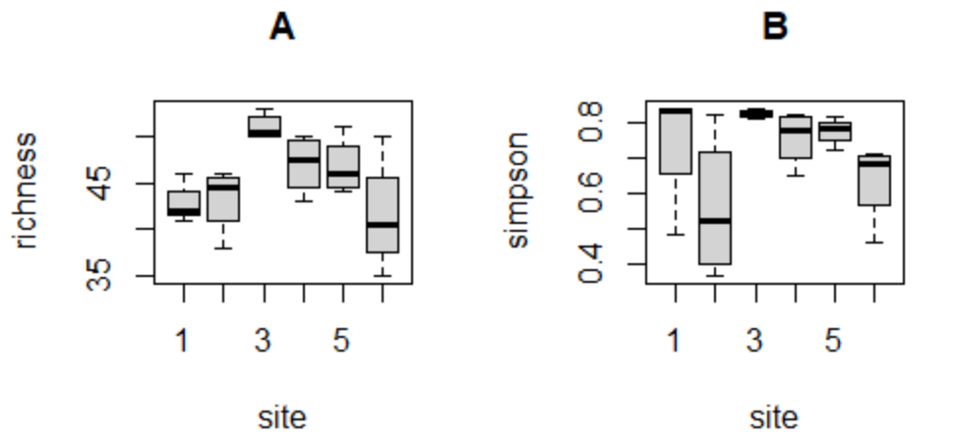
Figure 2. Boxplot A portraying the richness of OTU’s found at each site and Boxplot B portraying the Simpsons index calculated for each site.

To evaluate the alpha diversity of our samples, A summary 1-way anova was used to look at any significant differences found in OTU richness across each location tested. A significant difference was found (DF= 5, F value= 3.831, P VALUE = 0.0154) and a pair-wise comparison test was performed to assess where the significant difference is located. Pair-wise test showed significant difference between sites 1-3 (p-value= 0.04) and 6-3(p-value= 0.01) with site 3 being the common denominator. A visual representation of this can be found in figure 2A as both sites 1 and 6 are furthest away from site 3. A potential explanation for the significant difference in richness maybe a result of the increased leaf litter presence observed in table 1. Causing addition of new nutrients and OTUS. Other studies have observed changes to alpha diversity believed to be the result of the similar factors (Epele, Brand and Miserendino, 2019).
However, no significant differences were found with the Simpson’s index (SI) (DF= 5, F value= 2.521, p-value= 0.0674), and the pair-wise comparison tests, despite this we can extrapolate from figure 2B that sites 1,3,4,5 are very diverse, as these sites tested >0.800 for the Simpson’s index. Sites 2 (SI=0.610) and 6 (SI=0.670) were less diverse (Sagar and P, 2012).
3.3 Evaluation of Beta diversity- comparison of each site.
In this section of the results, the focus lies on the Beta diversity, which evaluates the total Community Composition as a whole and compares them to illustrate which sites were similar in composition and diversity.
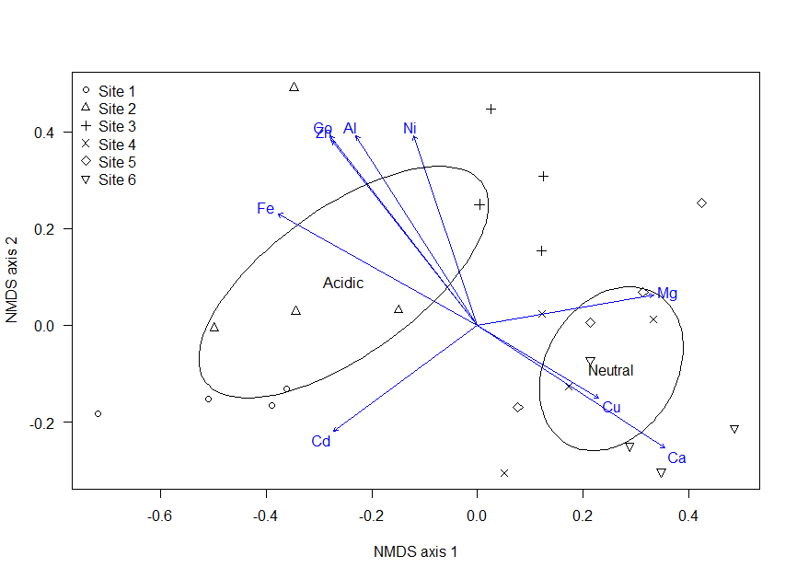
Figure 3. Shows an NMDS plot of the community composition of each site and it’s four replicate repeats. And what abiotic factors: PH and heavy metal density influence which sites. (NMDS stress,0.163)

The results collected here show the calculated similarity in community composition between all sites using the Bray-Curtis dissimilarity measures, NMDS plot. An Anosim test was used on the NMDS to analyse if there was any significant difference in acidic and neutral sites. A significant difference in community composition between acidic and neutral sites was discovered (r stat= 0.4733, P value= 0.01). This can also be visually signified on the NMDS plot as there is no overlap between PH variables. numerous studies have begun to identify Ph as one of the potential drivers of community change in lotic environments (Chen et al., 2021), like how Ph is thought to be the main cause in community change in soil (Fierer, Bradford and Jackson, 2007). The studies, like ours have shown significant differences in community composition in sites with opposing PHs (Or, Shtrasler and Gophna, 2012).

3.3.1 An Overview of the water composition: heavy metal concentration at each site
METAL NAME | MAGENSIUM (MG) | CALCIUM (CA) | IRON  (FE) | COBLAT (CO) | NICKEL (NI) | ZINC (ZN) | CADIUM  (CD) | ALUMINIUM  (AL)
P-VALUE | 0.004 | 0.001 | 0.001 | 0.001 | 0.002 | 0.001 | 0.013 | 0.002
NMDS 1 | 0.98311 | 0.81387 | -0.85264 | -0.57952 | -0.29314 | -0.58590 | -0.78014 | -0.50577
NMDS 2 | 0.18301 | 0.58105 | 0.52251 | 0.81496 | 0.95607 | 0.81038 | -0.62561 | 0.86267
TABLE 2. Shows the results from an environmental fit, showing the relationship between 8 out of 16 metals that are significantly correlated with Bray-Curtis NMDS
From table 2 we can extrapolate that magnesium and calcium are the only positive collations found at both NMDS 1 and NMDS 2. While the rest of the metals are negative at NMDS 1, other than cadmium that has negative correlations for both NMDS 1 and 2.
Site | pH | Mg | Ca | Fe | Co | Ni | Zn | Cd | Al | Total Metal
1 | 4.82 | 4.313 | 9.901 | 3.241 | 0.006 | 0.018 | 0.093 | 0.0013 | 1.839 | 36.514
2 | 4.78 | 4.899 | 10.047 | 2.556 | 0.008 | 0.021 | 0.101 | 0.0006 | 1.803 | 35.833
3 | 5.23 | 5.861 | 12.575 | 2.641 | 0.008 | 0.023 | 0.117 | 0.0000 | 2.105 | 44.489
4 | 7.05 | 5.229 | 20.838 | 1.682 | 0.003 | 0.019 | 0.072 | 0.0000 | 1.611 | 49.808
5 | 6.89 | 4.955 | 27.432 | 1.966 | 0.004 | 0.017 | 0.057 | 0.0008 | 1.316 | 58.320
6 | 6.79 | 6.1596 | 33.459 | 1.457 | 0.003 | 0.015 | 0.040 | 0.0005 | 0.882 | 58.283
Table 3. shows a calculated average of the significant metals (Mg/L) found in the environmental fit alongside the PH and total metals found at each site.
The results gathered here show the concentration of significant metals identified through NMDs environmental fit. As seen from table 3. Calcium (Ca) is the most concentrated metal found followed by magnesium (Mg), and iron (Fe). The results also illustrate a potential relationship between total metals concentration and PH. As a result, a correlation test was used and it revealed a significant positive correlation between Ph and total metals (p-value = <0.001, cor =0.839). indicating that as Ph rises (becomes more neutral) there is an increase in dissolved metals. However, this is somewhat unique to our study with other studies finding the opposite to be true. That a more acidic (lower PH) increased solubility of metal ions causing a larger spike to total metal concentrations (Bosserman, 1985, Cánovas, Riera, Carrero and Olías, 2018).

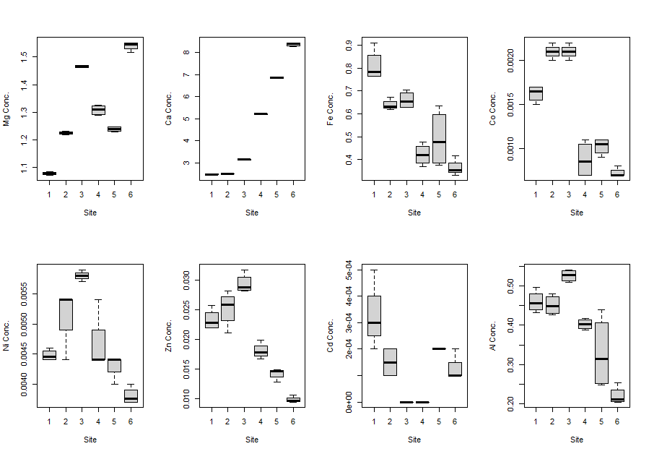
Figure 5: total Iron concentration found at each site.

Figure 4: total Calcium concentration found at each site.
Figure 6: total cobalt concentration found at each site.

Figure 4 exhibits a positive correlation between calcium concentration and sites tested. The concentration of calcium gets progressively higher from sites 1-6. however, this trend can not be said for iron and cobalt as they both show significant negative correlations with sites 1-6. The results of a correlation test also establish the positive relationship calcium has with PH in our study (P= <0.001, coeffeints= 0.715), and also cobalt showed a negative relationship with PH (P= <0.001, coefficients= -0.730). On the other hand, iron was not in the statistical correlation test between PH and our Icp data. However, a direct correlation test showed a highly significant positive correlation (p= <0.001, cor= -0.846) with iron and PH.
A possible reason for this is that the presence of iron can cause a complex geochemical and microbial reaction leaving the water more acidic and with a tint of orange, which was observed in table 1 (Johnson and Hallberg, 2005). This type of reaction is seen in acid mine drainage (AMD) cases; however, it occurs generally in the environment. In this case, it could result from an old coal quarry situated near site 2 called nelsons pit. These decommissioned pits may be the reason for the acidity in sites 1-3, similar to other studies. (Chen et al., 2018). However, it should be stated that upstream of site 1 is moorland, known to have high levels of iron and cobalt (Brinck, J., 1891, Dam, 1996).

3.3.2 The effect of Ph on OTU diversity.
OTU | Acidobacterium | Citrobacter | Desulfovibrio | Escherichia | Escherichia_shigella | Geobacter | Pantoea | Serratia
Significance | <0.001 | <0.001 | <0.001 | <0.001 | <0.001 | <0.001 | <0.001 | <0.001
Coefficients | -0.675 | 0.770 | -0.644 | 0.733 | 0.703 | -0.876 | 0.639 | 0.764
Table 4: The results of a correlation test showing the positive and negative significant relationship Ph had on OTU’S across all six sites.
The results illustrated here show the statistical relationship between Ph and OTU’S. Our results demonstrate that Serratia abundance had a significant positive correlation with Ph. The same distribution applied to; Citrobacter, Escherichia, Escherichia_shigella, and Pantoea. On the other hand, Geobacter, Desulfovibrio, and Acidobacterium were identified to have significant negative correlations with Ph. Studies have shown that, in general, microorganisms cannot cope under very low (acidic) or very high (alkali) PH values (Islam et al., 2005). These conditions increase the chance of proteins becoming denatured and the opportunity for exposed microbial cell components to be directly damaged (López-Archilla, Marin and Amils, 2001). However, some bacteria have adapted to handle these extreme conditions, and they are highly specialised to grow in those environments. Bactria like Acidobacterium found in the literature regarding highly acidic PHs (Jones et al., 2009); however, unlike acidobacterium, an OTU considered to be out of place by outside literature is Geobacter. Geobacter is a neutrophile; however, it is significantly negatively correlated with Ph in our study (Table 4), indicating acidophile. (López-Archilla, Marin and Amils, 2001).

3.3.3 The effect of certain significant metals on OTU diversity.
NAME | Acidobacterium | Acidothermus | Desulfovibrio | Geobacter | Pseudomonas
Significance | <0.001 | <0.001 | <0.001 | <0.001 | <0.001
Coefficients | -0.917 | -0.851 | -0.902 | -0.762 | 0.691
Table 5. The results of a correlation test showing the significant positive and negative correlation iron concentration had on OTU
Name | Acidothermus | Geobacter
Significance | <0.001 | <0.001
Coefficients | 0.663 | 0.697
Table 6. The results of a correlation test showing the significant positive and negative correlation Cobalt concentration had on OTU
NAME | Acidobacterium | Acidothermus | Desulfovibrio | Geobacter | novosphingobium
Significance | <0.001 | <0.001 | <0.001 | <0.001 | <0.001
Coefficients | 0.699 | 0.741 | 0.785 | 0.746 | 0.700

Table 7. The results of a correlation test showing the significant positive and negative correlation Calcium concentration had on OTU
The results collected here explore three metals and how their concentration affect OTU diversity. Firstly, as seen in table 5, Geobacter is significantly positively correlated with iron (FE) concentration (p-value= <0.001). The same distribution characteristics are observed in Acidobacterium, Acidothermus, Desulfovibrio, and Novosphingobium. Secondly, in table 6, we can see the relationships between two OTUS determined to be significantly positively correlated with cobalt: Acidothermus and Geobacter. These two OTUS are both correlated with iron and cobalt. Lastly, as seen in table 7, Calcium concentrations are significantly negatively correlated with Acidobacterium, Acidothermus, Desulfovibrio, and Geobacter and have been identified to have a significant positive correlation with the Pseudomonas (p-value= <0.001). The results gathered here are as expected except for Geobacter. Similar studies have found Geobacter to positively correlate with PH and a negative correlation with iron; however, our study is the opposite of this (Burkhardt et al., 2011). As previously said, many specialised microorganisms occupy a niche that they are adapted. Being placed in different conditions should put the bacterium under great physiological stress (Islam et al., 2005).

3.4 Gamma diversity- Assessing the total abundance of OTU’s in relation to their distribution in the ecosystem.
This section of results looks at the total OTU abundance, and its distribution throughout the ecosystem.
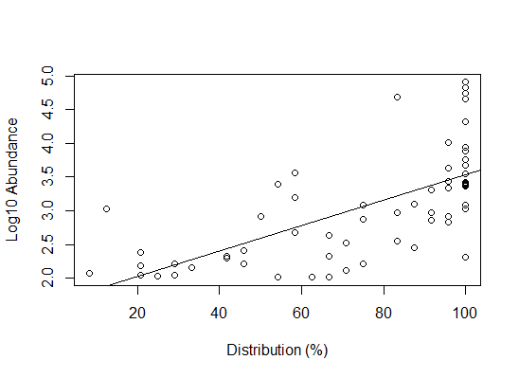
C
A
Figure 7. OTU Abundance correlated with its distribution percentage in all samples tested. Estimated cosmopolitan OTU= A, estimated endemic OTU= B
B

3.4.1 Ranked Community composition: Top three most abundant OTU’s calculated at each site.
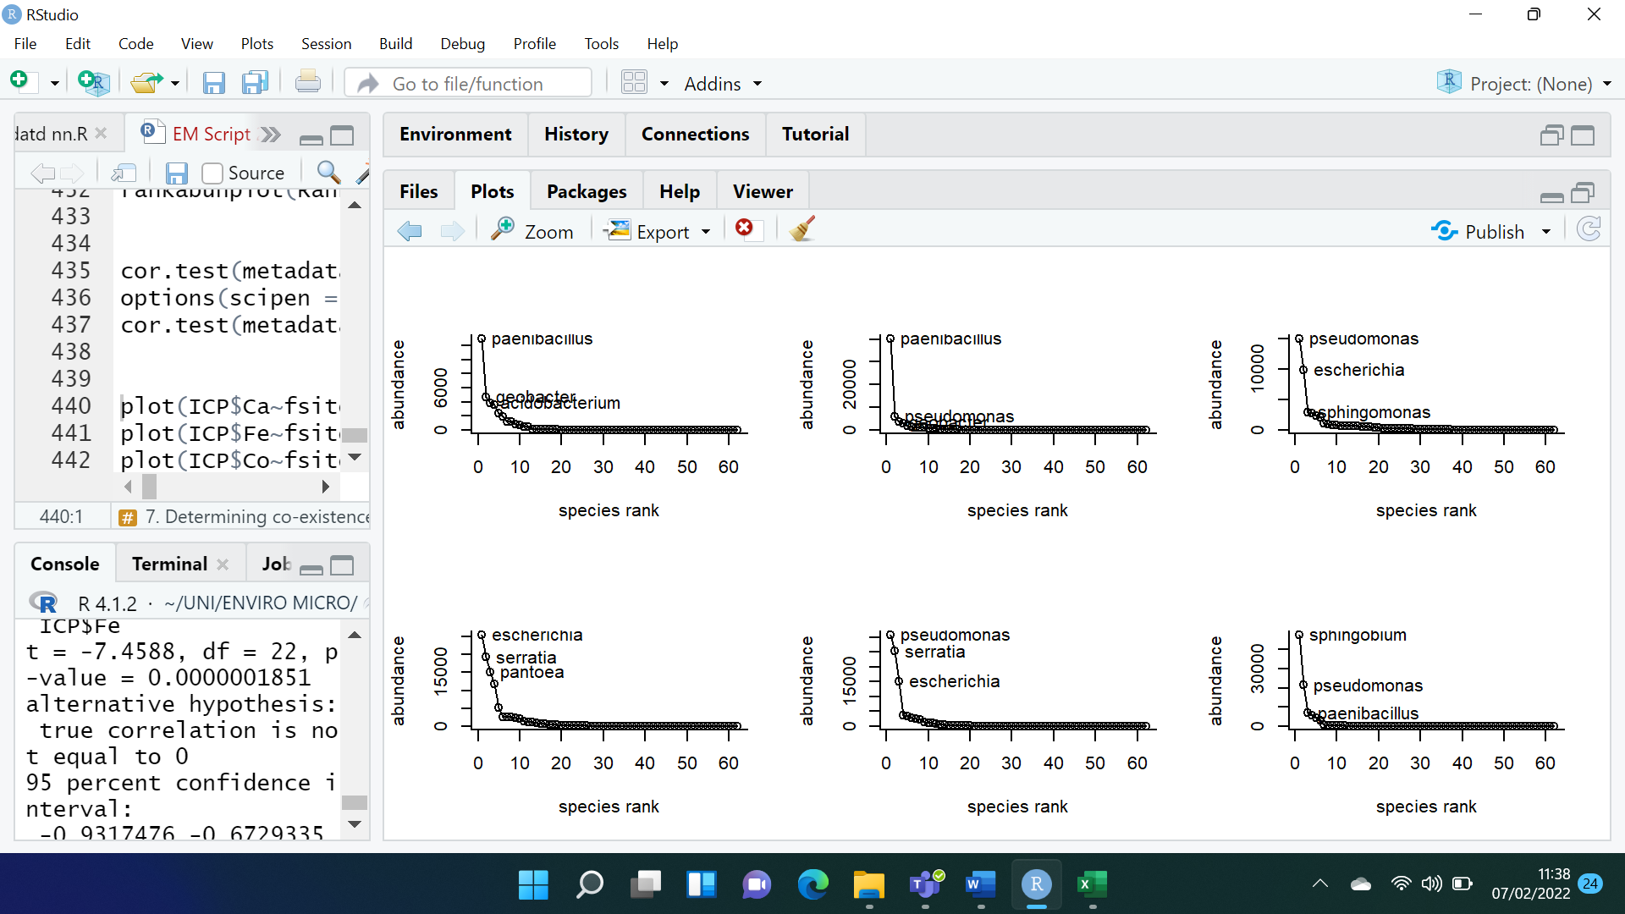Figure 8. the result of a rank-abundance test rankings the top 3 most abundant OTUS found at each site.

There is a significant positive correlation between distribution and abundance (r=0.444, p<0.001). This shows that most sites are dominated by the most abundant OTUs. As seen in figure 7 group A are the identified cosmopolitan OTU’S: pseudomonas, serratia, paenibacillus, and Escherichia. This is also supported by figure 8 as group A OTU’S are present in the top 3 ranking of OTU abundance per site. Seen in figure 7 is group B that demonstrate an abundant OTU that is low in distribution percentage this OTU has been identified as exiguobacterium. Group C was also named as acidithiobacillus and is shown to have 100% distribution among the sites but low abundance.
The results illustrated here are highly important as it suggest despite abiotic factors (Ph, metal concentration) influencing a great deal of OTUS there are OTUS that seem to be very resilient and can keep their abundance high across all sites tested (Borrego, Sabater and Proia, 2020). However, what’s most intriguing is group C: acidithiobacillus. As literature suggests a negative correlation with PH (López-Archilla, Marin and Amils, 2001). However, despite the disadvantage is distributed at 100% of all sites. This research heavily favours the EisE but the environment selects hypothesis as through our data are resilient OTUS found in locations that are highly disadvantageous to them (de Wit and Bouvier, 2006).
3.5 limitations
firstly, the study primarily focuses on the river and nothing else. We didn’t conder the wider environment that could have led to a change in abiotic and biotic interactions or could have provided greater context to the interactions our data presented.
secondly, we also failed to test many different abiotic factors like soil, sediment, particulates, and temperature properly. that could have given us a larger picture as to what was occurring in the ecosystem. E.g., the temperature was found to be a great driver in community change in other studies, however, we had only taken one measurement per site.
Lastly, human error. A team of twenty plus individuals were involved in the lab work. This is important as their may have been variation in skill, technique, and protocol that could have resulted in less reliable data.
3.6 future work

Firstly, increasing the scale of the study. Despite literature that suggest there could be significant changes in community compositions with sites <1km from each other Increasing the scale and allows us to test a broad range of habitat types and conditions granting us a better understanding on what abiotic factors influence community change.
Secondly, future work can consider seasonal change. As study shows community composition can shift greatly depending on the season (Paruch et al., 2020).

- CONCLUSION
The work presented has evaluated the effects of PH on bacterial community change and the effects of other abiotic factors working in unison to promote community compositional change. It has confirmed that PH is a significant driver of difference across sites tested, as it interacted with not only OTU richness and diversity but also the metals (nutrients) present. However, it was not completely successful as it revealed that there are OTUs that are cosmopolitan despite abiotic factors supposedly working against them.

REFRENCES
Introduction
- Astorga, A., Oksanen, J., Luoto, M., Soininen, J., Virtanen, R. and Muotka, T., 2011. Distance decay of similarity in freshwater communities: do macro- and microorganisms follow the same rules?. Global Ecology and Biogeography, 21(3), pp.365-375.
- Beisner, B., Peres-Neto, P., Lindström, E., Barnett, A. and Longhi, M., 2006. THE ROLE OF ENVIRONMENTAL AND SPATIAL PROCESSES IN STRUCTURING LAKE COMMUNITIES FROM BACTERIA TO FISH. Ecology, 87(12), pp.2985-2991.
- Bell, T., 2010. Experimental tests of the bacterial distance–decay relationship. The ISME Journal, 4(11), pp.1357-1365.
- de Wit, R. and Bouvier, T., 2006. 'Everything is everywhere, but, the environment selects'; what did Baas Becking and Beijerinck really say?. Environmental Microbiology, 8(4), pp.755-758.
- FONTANETO, D., BARRACLOUGH, T., CHEN, K., RICCI, C. and HERNIOU, E., 2008. Molecular evidence for broad-scale distributions in bdelloid rotifers: everything is not everywhere but most things are very widespread. Molecular Ecology, [online] 17(13), pp.3136-3146. Available at: <https://onlinelibrary.wiley.com/doi/abs/10.1111/j.1365-294X.2008.03806.x>.
- Gray, T. and Campbell, R., 1980. Microbial Ecology. The Journal of Ecology, 68(1), p.344.
- Guerrero, R., 2015. Year’s comments for 2015. International Microbiology, 18(4), pp.203-208.
- Gweon, H., Bowes, M., Moorhouse, H., Oliver, A., Bailey, M., Acreman, M. and Read, D., 2020. Contrasting community assembly processes structure lotic bacteria metacommunities along the river continuum. Environmental Microbiology, [online] 23(1), pp.484-498. Available at: <https://sfamjournals.onlinelibrary.wiley.com/doi/full/10.1111/1462-2920.15337#emi15337-bib-0022>.
- Hou, D., Huang, Z., Zeng, S., Liu, J., Wei, D., Deng, X., Weng, S., He, Z. and He, J., 2017. Environmental Factors Shape Water Microbial Community Structure and Function in Shrimp Cultural Enclosure Ecosystems. Frontiers in Microbiology, 8.
- IVARS-MARTÍNEZ, E., D’AURIA, G., RODRÍGUEZ-VALERA, F., SÁNCHEZ-PORRO, C., VENTOSA, A., JOINT, I. and MÜHLING, M., 2008. Biogeography of the ubiquitous marine bacteriumAlteromonas macleodiidetermined by multilocus sequence analysis. Molecular Ecology, 17(18), pp.4092-4106.
- Kellogg, C. and Griffin, D., 2006. Aerobiology and the global transport of desert dust. Trends in Ecology & Evolution, 21(11), pp.638-644.
- Lijuan, R., Dan, H., Peng, X., Yujing, W. and Qinglong, W., 2014. Bacterial diversity and ecological function in lake water bodies. Biodiversity Science, 21(4), pp.421-432.
- Morris, R., Rappé, M., Connon, S., Vergin, K., Siebold, W., Carlson, C. and Giovannoni, S., 2002. SAR11 clade dominates ocean surface bacterioplankton communities. Nature, 420(6917), pp.806-810.
- Paruch, L., Paruch, A., Eiken, H., Skogen, M. and Sørheim, R., 2020. Seasonal dynamics of lotic bacterial communities assessed by 16S rRNA gene amplicon deep sequencing. Scientific Reports, [online] 10(1). Available at: <https://www.nature.com/articles/s41598-020-73293-9>.
- Prosser, J., Bohannan, B., Curtis, T., Ellis, R., Firestone, M., Freckleton, R., Green, J., Green, L., Killham, K., Lennon, J., Osborn, A., Solan, M., van der Gast, C. and Young, J., 2007. The role of ecological theory in microbial ecology. Nature Reviews Microbiology, 5(5), pp.384-392.
- Saxena, G., Bharagava, R., Kaithwas, G. and Raj, A., 2014. Microbial indicators, pathogens and methods for their monitoring in water environment. Journal of Water and Health, 13(2), pp.319-339.
- Smith, H. and Wilkinson, D., 2007. Not all free-living microorganisms have cosmopolitan distributions ? the case of Nebela (Apodera) vas Certes (Protozoa: Amoebozoa: Arcellinida). Journal of Biogeography, 34(10), pp.1822-1831.
- Vannote, R., Minshall, G., Cummins, K., Sedell, J. and Cushing, C., 1980. The River Continuum Concept. Canadian Journal of Fisheries and Aquatic Sciences, 37(1), pp.130-137.
- Zeglin, L., 2015. Stream microbial diversity in response to environmental changes: review and synthesis of existing research. Frontiers in Microbiology, 6.

Methods
- Callahan, B. J., McMurdie, P. J., Rosen, M. J., Han, A. W., Johnson, A. J. A. and Holmes, S. P. (2016) 'DADA2: High-resolution sample inference from Illumina amplicon data.' Nature Methods, 13, 05/23/online, p. 581.

- DeSantis, T. Z., Hugenholtz, P., Larsen, N., Rojas, M., Brodie, E. L., Keller, K., Huber, T., Dalevi, D., Hu, P. and Andersen, G. L. (2006) 'Greengenes, a Chimera-Checked 16S rRNA Gene Database and Workbench Compatible with ARB.' Applied and Environmental Microbiology, 72(7), July 1, 2006, pp. 5069-5072.

- Kozich, J. J., Westcott, S. L., Baxter, N. T., Highlander, S. K. and Schloss, P. D. (2013) 'Development of a Dual-Index Sequencing Strategy and Curation Pipeline for Analyzing Amplicon Sequence Data on the MiSeq Illumina Sequencing Platform.' Applied and Environmental Microbiology, 79(17), 04/01/received 06/13/accepted, pp. 5112-5120.

- R Core Team (2021). R: A language and environment for statistical computing. R Foundation for Statistical Computing, Vienna, Austria. URL https://www.R-project.org/.

- Jari Oksanen, F. Guillaume Blanchet, Michael Friendly, Roeland Kindt, Pierre Legendre, Dan McGlinn, Peter R. Minchin, R. B. O'Hara, Gavin L. Simpson, Peter Solymos, M. Henry H. Stevens, Eduard Szoecs and Helene Wagner (2020). vegan: Community Ecology Package. R package version 2.5-7. https://CRAN.R-project.org/package=vegan

- Kindt, R. & Coe, R. (2005) Tree diversity analysis. A manual and software for common statistical methods for ecological and biodiversity studies. World Agroforestry Centre (ICRAF), Nairobi. ISBN 92-9059-179-X.

RESULTS and Discussion.
- Borrego, C., Sabater, S. and Proia, L., 2020. Lifestyle preferences drive the structure and diversity of bacterial and archaeal communities in a small riverine reservoir. Scientific Reports, 10(1).
- Bosserman, R., 1985. R. Trivers: Social Evolution. Menlo Park, California: The Benjamin/Cummings Publishing Company, Inc., 1985. Behavioral Science, 30(4), pp.240-242.
- Brinck, J., 1891. Report On Experiments On Nutrition Of Muscle. The British Medical Journal, pp.181-183.
- Burkhardt, E., Bischoff, S., Akob, D., Büchel, G. and Küsel, K., 2011. Heavy Metal Tolerance of Fe(III)-Reducing Microbial Communities in Contaminated Creek Bank Soils. Applied and Environmental Microbiology, 77(9), pp.3132-3136.
- Cánovas, C., Riera, J., Carrero, S. and Olías, M., 2018. Dissolved and particulate metal fluxes in an AMD-affected stream under different hydrological conditions: The Odiel River (SW Spain). CATENA, 165, pp.414-424.
- Chen, D., Feng, Q., Li, W., Song, Y. and Zhao, C., 2021. Effects of acid drainage from abandoned coal mines on the microbial community of Shandi River sediment, Shanxi Province. International Journal of Coal Science & Technology, 8(4), pp.756-766.
- Chen, D., Feng, Q., Liang, H., Gao, B. and Alam, E., 2018. Distribution characteristics and ecological risk assessment of polycyclic aromatic hydrocarbons (PAHs) in underground coal mining environment of Xuzhou. Human and Ecological Risk Assessment: An International Journal, 25(6), pp.1564-1578.
- Dam, H., 1996. Partial recovery of moorland pools from acidification: Indications by chemistry and diatoms. Netherlands Journal of Aquatic Ecology, 30(2-3), pp.203-218.
- Epele, L., Brand, C. and Miserendino, M., 2019. Ecological drivers of alpha and beta diversity of freshwater invertebrates in arid and semiarid Patagonia (Argentina). Science of The Total Environment, 678, pp.62-73.
- Fierer, N., Bradford, M. and Jackson, R., 2007. TOWARD AN ECOLOGICAL CLASSIFICATION OF SOIL BACTERIA. Ecology, 88(6), pp.1354-1364.
- Islam, F., Boothman, C., Gault, A., Polya, D. and Lloyd, J., 2005. Potential role of the Fe(III)-reducing bacteria Geobacter and Geothrix in controlling arsenic solubility in Bengal delta sediments. Mineralogical Magazine, 69(5), pp.865-875.
- Johnson, D. and Hallberg, K., 2005. Acid mine drainage remediation options: a review. Science of The Total Environment, 338(1-2), pp.3-14.
- Jones, R., Robeson, M., Lauber, C., Hamady, M., Knight, R. and Fierer, N., 2009. A comprehensive survey of soil acidobacterial diversity using pyrosequencing and clone library analyses. The ISME Journal, 3(4), pp.442-453.
- López-Archilla, A., Marin, I. and Amils, R., 2001. Microbial Community Composition and Ecology of an Acidic Aquatic Environment: The Tinto River, Spain. Microbial Ecology, 41(1), pp.20-35.
- Or, A., Shtrasler, L. and Gophna, U., 2012. Fine-Scale Temporal Dynamics of a Fragmented Lotic Microbial Ecosystem. Scientific Reports, 2(1).
- Sagar, R. and P, G., 2012. Environmental Skeptics and Critics, 2012,. 1st ed. India: Department of Environmental Studies, University of Delhi, pp.23-24.

